Customer-specific screw shortening

Customer name

Screws with centering
Please choose the thread type and fill in the length “x2”.

Select | Thread type | Centering diameter d1 + standard centering length “x1” [mm] | Total length “x2”  [mm] | Max. length [mm]
☐ | Tr3,5x1 | 2h10; L=7 |  | 200
☐ | Tr5x2 | 3h7; L=7 |  | 300
☐ | Tr5x5 | 3h7; L=7 |  | 300
☐ | Tr6x1 | 4h7; L=7 |  | 300
☐ | Tr6x2 | 4h7; L=7 |  | 300
☐ | Tr10x2 | 8h7; L=10 |  | 300
☐ | Tr10x6 | 8h7; L=10 |  | 300
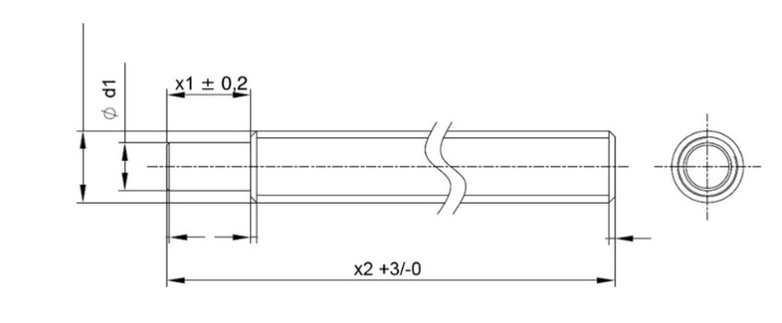
Screws without centering
Please choose the thread type and fill in the length “x2”.
Select | Thread type | Total length “x2” [mm] | Max. length [mm]
☐ | Tr3,5x1 |  | 500
☐ | Tr5x2 |  | 1000
☐ | Tr5x5 |  | 1050
☐ | Tr6x1 |  | 1050
☐ | Tr6x2 |  | 1050
☐ | Tr10x2 |  | 1050
☐ | Tr10x6 |  | 1000
☐ | M6x1 |  | 1000
Please note:
For all other types of screw modifications we have minimum order quantities. Please send your modification request to our sales department, together with a detailed drawing: sales@nanotec.de.

